CENTRAL ASSOCIATION OF RUSSIAN TEACHERS OF AMERICA
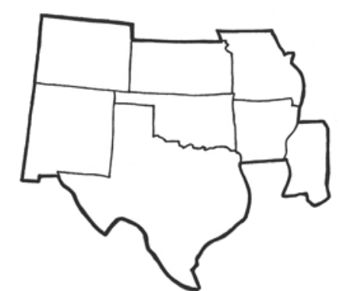

"Нравственность человека видна в его отношении к слову". — Л. Н. Толстой

Twenty-Eighth Annual Conference
March 27-29, 2026
DoubleTree by Hilton
Austin, TX

Name: | Institution:
E-mail: | Phone:
Address:

TYPE OF MEMBERSHIP (check one and highlight/circle appropriate level)
Pre-College Teacher/ Instructor/ Lecturer/ Asst. Professor - $25 |  |  | Associate/ Full Professor - $40
Student - $20 | Retired - $20 | Publisher/ Administrator - $40 |  | Lifetime - $500

Note: All presenters, including international, must be CARTA members.

International Members: CARTA will host one virtual session for international members only on Saturday, March 21, 9:00-11:00 Central Daylight Time (GMT -5), via Zoom. The link will be provided for registered conference participants.

REGISTRATION (check one)
Member Participant - $120 | Non-Member Participant - $170 | On-Site Registration - $200
Retired Member - $75 | Student - $50 | International Virtual - $50

SPECIAL DONATIONS
CARTA General Fund- $ | Lis Collins Scholarship Fund - $

TOTAL PAYMENT: $________

Please pre-register by sending this form with a check payable to CARTA to Dr. Mara Sukholutskaya, CARTA, Department of English and Languages, East Central University, PMB W-7, Ada, OK, 74820. Please pre-register no later than February 26, 2026, to receive a link to the virtual session and avoid the on-site registration fee.

You may also pay with your PayPal account to centralrussianteachers@gmail.com. To avoid the fee, please use the "Sending to a friend" option through your bank. If you use Paypal, please send this form to the email address above.

